Asset Accounting – In house Capitalization – User Manual

- Create asset in AS01

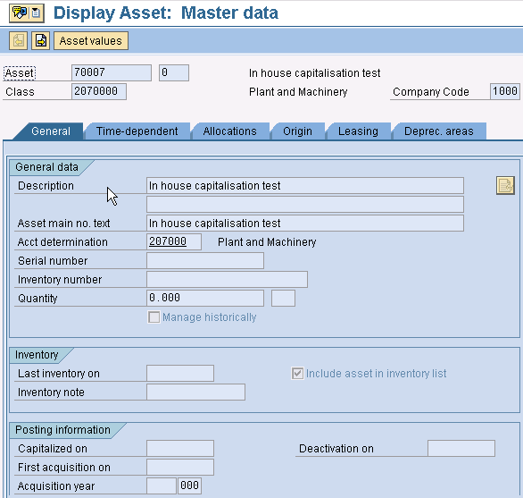

- Use Transaction MB1A to capitalize in-house produced material
(In-house capitalization without Asset Module - Movement Type 291 can be used)

Use Movement Type 241 to capitalize the in-house manufactured material
